

GOOD PRACTICES TASK FORCES
ISPOR Good Practices Task Forces develop expert, consensus guidance reports on international good practice standards for conducting outcomes research (clinical, economic, and patient-centered outcomes) or for using outcomes research in health care decisions. These reports are highly cited recommendations that set international standards for outcomes research and its use in healthcare decision making.

Inherent in these reports is a focus on methods and approaches to conduct research to inform healthcare decisions and improve health. ISPOR Task Force reports include not only design and approaches of conducting research, but also how studies or analyses should be performed and how results should be disseminated. These reports address areas where there is consensus and issues where there are gaps or controversies that have not been resolved or integrated into the HEOR literature. Overall, they inform the HEOR community about the current state of good practices in a domain and state-of-the-art techniques.

TASK FORCE PROPOSAL FORMAT
- TITLE OF TASK FORCE: The title of the task force should succinctly and clearly state the topic.

- BACKGROUND: Provide foundational information on the proposed topic in sufficient detail to permit an assessment by the ISPOR Health Science Policy Council members. Describe the methods and/or their application to healthcare as well as current issues. It may be reasonable to describe how the methods have been used by other disciplines.
It is helpful to provide definitions, especially if your topic is relatively new or if it is similar to another topic. For example, it would be important to define quality assessment (QA) in a model validation proposal. QA and model validation are closely related but distinct processes, and they often overlap in practice. Clarifying the difference will make the proposal clearer to committee members.
- OBJECTIVE: Clearly define the purpose of the good practices task force. The objective statement articulates specifically what gap in guidance the task force is going to fill.

- RATIONALE: The proposal must include a statement on why this good practice guidance is important to the HEOR community. Why is this an important area to establish an ISPOR Good Practices Task Force? What is the impact it will have or how will it impact the scientific community?

The rationale should be supported by empirical studies that resolve or identify underlying uncertainty about research methods. These studies / evidence will be part of your bibliography (See Section 10).

Specifically, the rationale should address the following criteria:
  - Necessity: Why is this task force required? What are the controversies, issues, or concerns the task force will address?
It should be noted that proposals to update an existing task force report will be evaluated by the same criteria. The justification for an update must be clearly described just as in a new proposal.
  - Methodology Oriented: Inherent in ISPOR Good Practices Task Force reports is a focus on methods and approaches to conducting research to inform healthcare decisions and improve health. This includes not only the methods of conducting research, but how analyses should be performed, as well as how the results of studies should be disseminated.
  - Relevance to ISPOR’s mission and its members: The task force must be relevant to ISPOR’s mission: to advance health economics and outcomes research excellence to improve decision making for health globally.
  - Durability: The topic of interest should not be a passing trend. It should be able to stand the test of time.
  - Broad applicability - The task force should not focus on a particular product, technology or program, but rather be applicable to a wide array of technologies, situations and geographic areas. ISPOR is a global organization.
  - Evidence-based – The rationale should be supported by empirical studies that resolve or identify underlying uncertainty about research methods. The rationale should also discuss the implications of using differing approaches to study the phenomena and the expected outcomes from the task force in terms of obtaining consensus or providing recommendations. If insufficient studies are available to resolve uncertainty for most issues facing the task force, then the emerging task force designation is appropriate.

- PRIORITY: The proposal must include a statement why this good practice guidance should be a priority specifically for ISPOR. Because substantial resources are consumed with task force activities, the proposal should articulate why the task force should be conducted.

Briefly address how this task force aligns with and supports ISPOR's mission and ISPOR’s Strategic Plan 2030.

ISPOR’s mission is to advance health economics and outcomes research excellence to improve decision making for health globally.

The specific areas for task forces in ISPOR’s Strategic Plan 2030 are:
Goal 1: Lead the definition, measurement, and use of value for health decision making, specifically, Objective 1.2: Identify, create, and advance approaches to improve the measurement and use of value.
Goal 2: Be the trusted HEOR authority that leads change in health policy worldwide, specifically, Objective 2.2: Establish, advance, and facilitate the use of ISPOR good practices.
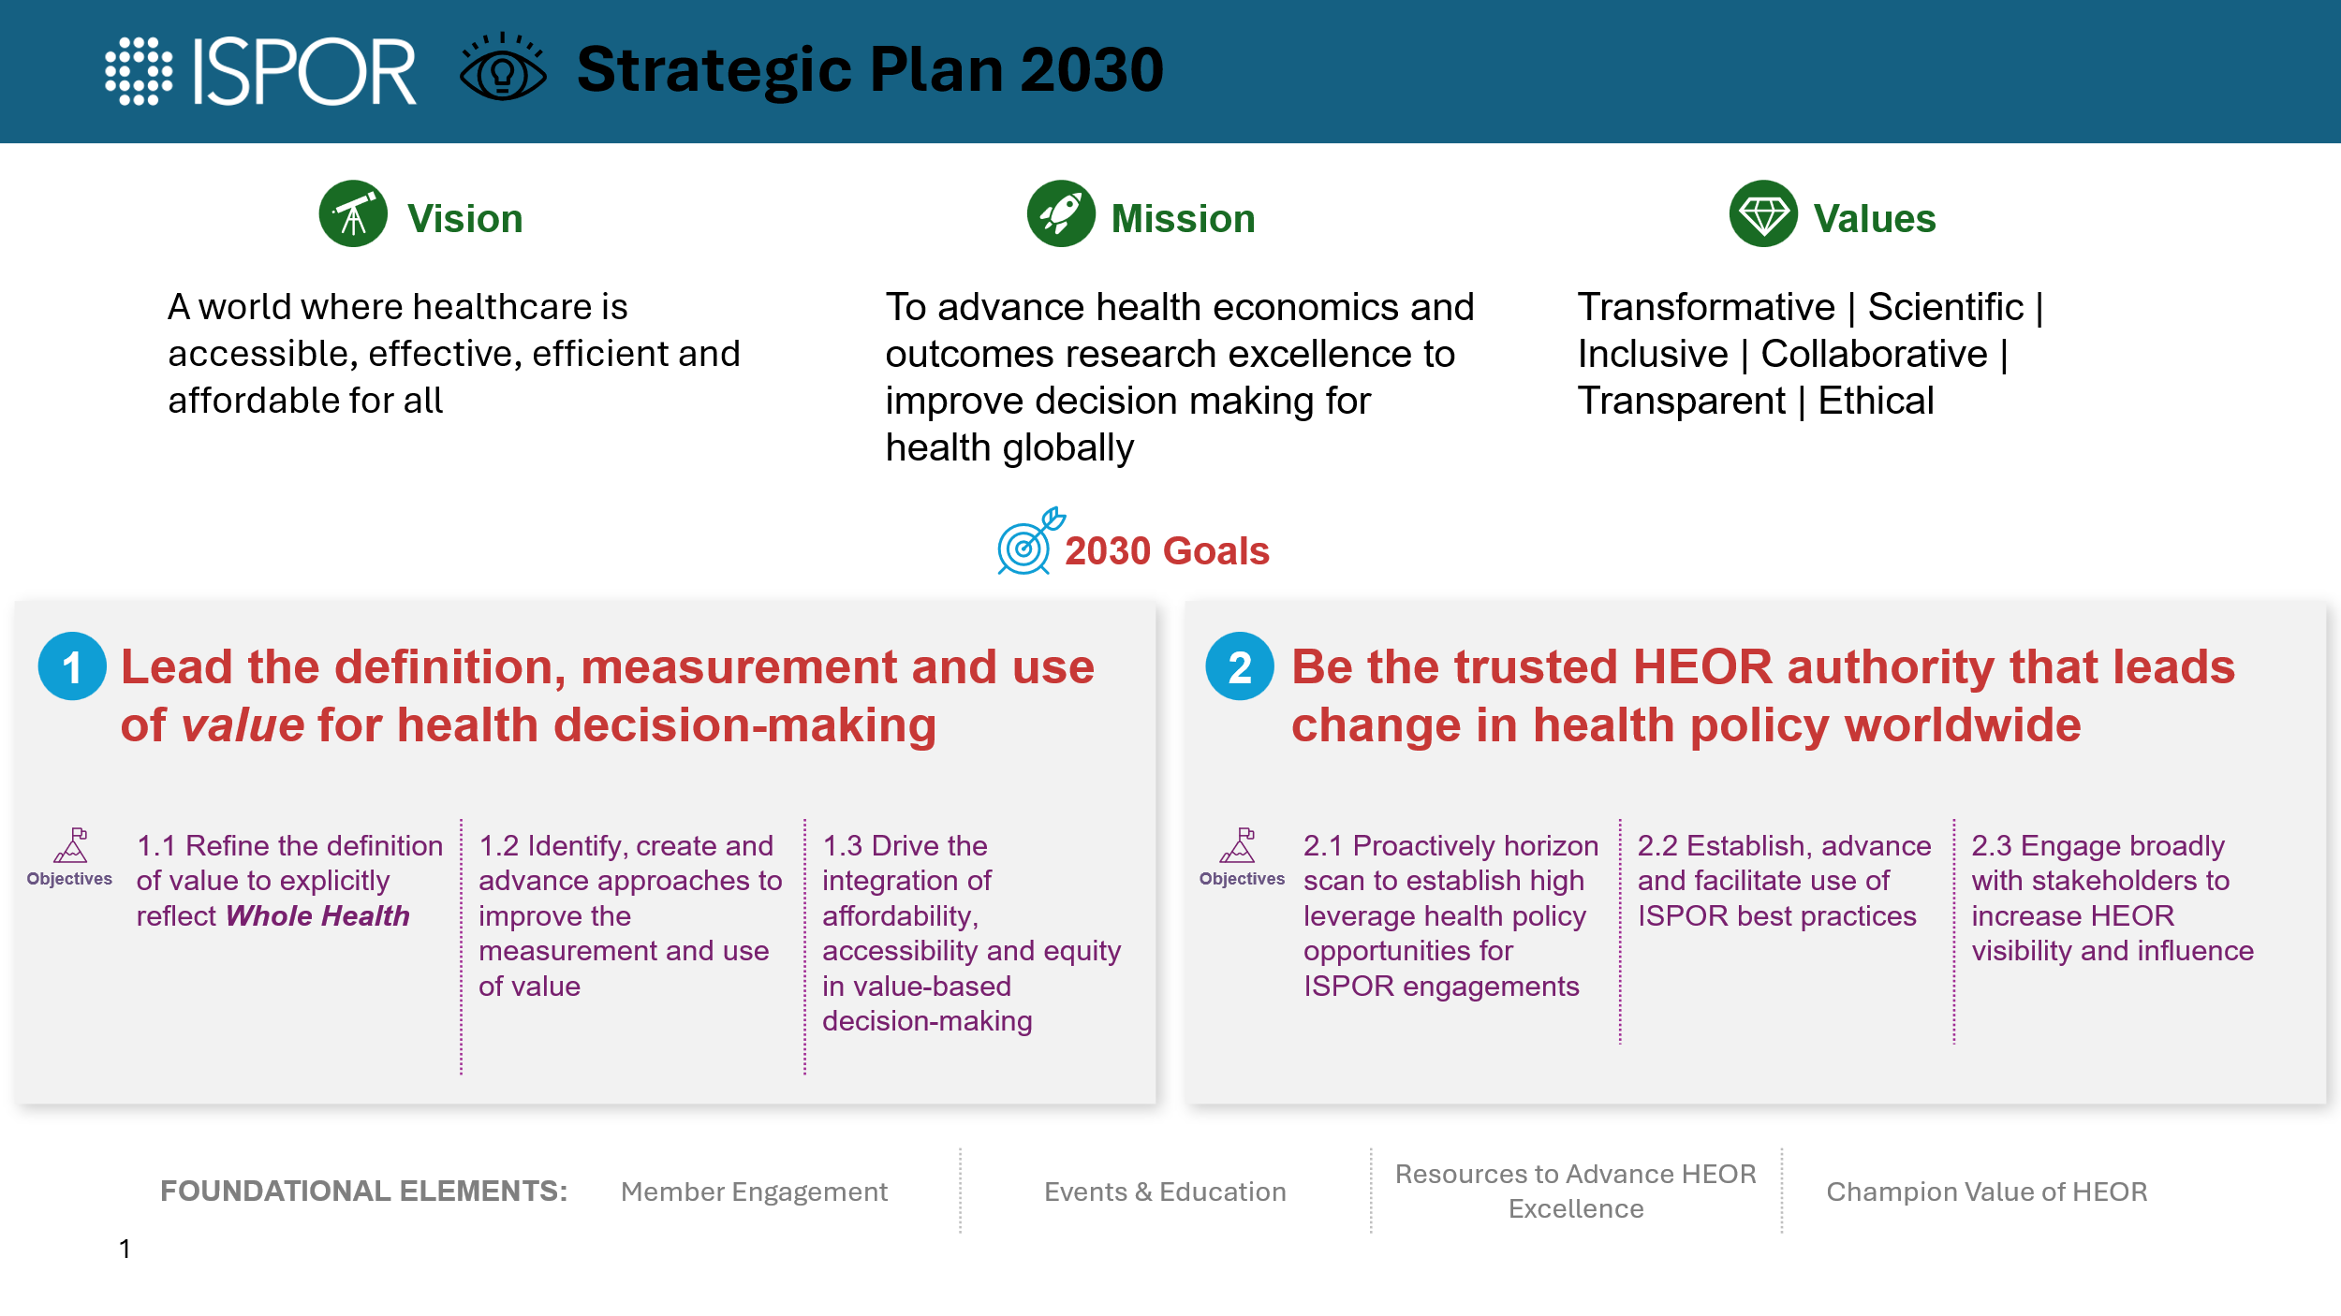

In addition, discuss whether and how the proposal addresses the ISPOR Science Strategy. For example, if the proposal falls in the patient-centered research category, please review that category and explain how the proposal addresses one of those stated focus areas.

Please note that it is not mandatory that your proposal addresses an ISPOR Science Strategy topic – new ideas are always welcome – but this may help determine its priority.
If other groups outside of ISPOR are working on related recommendations or guidance documents, the proposal should clearly state why those activities are not sufficient to address the issue and what the ISPOR activity would add to those efforts.
- LITERATURE REVIEW: Please see literature review addendum at the end of this document and include the description of your review in the bibliography section of the proposal (See Section 10). For an example literature review description, please see addendum.
- OUTLINE FOR THE REPORT: Please provide a detailed outline for the report.
- CONTENT: Task force reports contain specific recommendations and recommendation support information. Provide an in-depth overview of the issues to address if not detailed in the outline. (See sample task force proposals for level of detail.)
- Please note that the length of the report should be 4,000 words prior to addressing comments received during the two rounds review. Maximum report length is 5,000 words with up to 6 tables and figures.
- Please keep scope in mind. It must be very narrow for a 5,000-word report.
- A task force should expect to produce 1 manuscript of no more than 5,000 words. If initiators propose more than one manuscript or a longer manuscript, it must be well-justified and agreed to in advance.
- If, during the course of the task force’s work, a compelling need emerges to increase the number of manuscripts, this change must be agreed to a priori by the TFRC based on a written justification from the task force co-chairs.
- TASK FORCE MEMBERSHIP: Typically, it consists of ~10 leadership members including co-chairs.
- Members should be selected with expertise in the topic and represent the various stakeholders involved (academia, research organizations, government, regulatory agencies and commercial entities).
- Diversity in opinion / perspective is important for ISPOR consensus task force reports. Membership is limited to two members per organization. This holds for academic training as well.

- Please note that task force membership should include international representation.

- At least one decision maker / payer / regulator / assessor (as appropriate for the proposal topic) should be included on the task force. There is no limit on the number of decision makers that can be invited to join a task force.
- While task force member experts do NOT need to be ISPOR members, the initiators (co-chairs) should be ISPOR members in good standing.
- For each proposed member of the task force, please include the name, degrees, title, affiliation, city, state / country, an email address, a link to their online profile PLUS a brief description of their specific expertise in relation to the task force’s topic.

- Please compile an international list of designated primary reviewers with subject matter expertise in the topic. Please include the name, degrees, title, affiliation, city, state / country and their email address.
Designated primary reviewers add to the diversity of perspective, and their feedback improves the manuscript. There is no limit on the number of designated primary reviewers.
- Your bibliography will be very useful for task force membership selection and compiling the list of designated primary reviewers. In addition, the ISPOR Presentations Database can be helpful as well.
- Commitment: Please note that voluntary service on a task force is prestigious, but it can also be demanding. All task force members are expected to actively participate in ALL stages of report development, writing, reviewing, revising, and addressing comments, as well as attending monthly teleconferences for co-authorship.
If an invited task force member cannot commit to actively participate, they should be invited as designated primary reviewers and be acknowledged as such.
- If assistance is needed with member selection, please contact the ISPOR Task Force Staff Liaison at taskforce@ispor.org

- BIBLIOGRAPHY: Should be comprehensive in terms of including seminal articles on the proposal topic. The bibliography should contain the relevant evidence that supports the need for the task force’s formation. Please scroll down for TFRC direction on reviews in the addendum.

- TIMELINE: Define specific work activities from the outline. It should include abstract submission and presentation planning at ISPOR Annual and/or European conferences and 2 formal review rounds for consensus development. The timeline should extend to submission to Value in Health. Please see the proposal example (See Section 12) for a sample timeline.

- PROPOSAL EXAMPLE: The ISPOR Task Force Staff Liaison will provide a previously submitted proposal to follow as an example.

- ASSISTANCE: In the early stages of task force proposal development, the ISPOR Task Force Staff Liaison can answer questions and provide feedback on proposal drafts for clarity, scope and completeness. The liaison can also assist with the task force’s membership. The liaison can be reached at: taskforce@ispor.org

- SUBMISSION: Please submit your proposal to the ISPOR Task Force Staff Liaison at taskforce@ispor.org
Please note that proposal submissions are rolling (ongoing); there is no due date for submissions. However, it is useful for planning purposes to stay in contact with the staff liaison regarding proposal status and an estimated submission month.
Note: Task Force proposals are evaluated in the order in which they are submitted to ISPOR.



Literature Review Addendum

With regard to strengthening future ISPOR Good Practices Task Force Reports (GP TFRs), the ISPOR Health Science Policy Council’s Task Force Review Committee, with input from Value in Health, has initiated a task force future-proofing project.

An aspect of this initiative is adding a literature review element to the task force proposal format. For publication of an ISPOR GP TFR in Value in Health, there is a need to have confidence that important literature related to the work has been identified and appropriately described.

The principle should be to identify key literature, to describe it accurately, and to review its quality with appropriate granularity given its relevance to the task force’s objectives. This literature should also be synthesized to articulate how it informs the task force’s focus and objectives.

Task force initiators (co-chairs) must describe their approach to a literature review, eg, a targeted review, and rationale to convey that this has been achieved in the task force proposal format. This is not considered a major policy change as any strong GP TFR should describe and review relevant literature—it is foundational. This additional note relates to the need for clarity in how this literature was identified and the review undertaken.

This website, the Duke University Medical Center Library & Archives, and the article, A Typology of Reviews: An Analysis of 14 Review Types and Associated Methodologies, outline different types of literature review and their constituent parts. These resources may be helpful to task force initiators in describing and justifying the type of review they conduct.

To be clear, the Task Force Review (TFR) Committee is NOT asking or requiring task force initiators to publish another paper (the literature review), although in some cases, they may be motivated to do so. For example, the task force co-chairs along with some task force members of the Generative AI for HEOR SLRs Task Force, conducted a rapid review before starting their task force, and consequently, wrote a literature review paper that has been submitted to Value in Health.

In addition, it should be noted that the task force co-chairs do not personally have to conduct the literature review. For example, this could be conducted by other members of the team, perhaps supported by an information specialist to identify literature and/or a supervised student, research associate or junior staff member.

Finally, with the advent of artificial intelligence tools for literature reviews (with due transparency and clarity), this process should be much faster and less onerous than in the past.

Example of a literature review description for a task force proposal

Literature review approach
Initial searches identified: 16,399 results searching for “cognition OR cognitive NOT cognitive behavioral therapy” and filtered for “clinical trials” AND “randomized controlled trial”, for the past 10 years (09/07/2026); and 19,234 records for the term “cognition” in clinicaltrials.gov (09/07/2026). Within clinicaltrials.gov, of the Phase 2 or 3, industry sponsored trials, the most frequent conditions listed (>10 trials) were in descending order Alzheimer’s disease and related dementias, rare diseases, cancers, Parkinson’s disease (including PD dementia), schizophrenia and psychosis, multiple sclerosis, and COVID-19.
Given the wide use of cognition assessment in clinical trials across a range of diseases and conditions, as well as measurement models (e.g., phase of development, position in hierarchy of endpoints, safety vs efficacy), a more targeted approach was applied to this initial overview.
FDA guidance documents were reviewed for language related to cognition assessment, and specific diseases and conditions were identified from clinicaltrials.gov and reviewed with respect to their measurement models. Additionally, public-facing FDA documents for drugs approved in rare disease indications from 2015 to the present were reviewed for the inclusion of other secondary and/or exploratory endpoints where aspects of cognitive functioning and adaptive abilities were measured.

